HOW CAN WE MAINTAIN AND ENHANCE ‘QUALITEACHING’ AND ‘QUALILEARNING’ IN TIMES OF CRISIS?

LAURA MURESAN
Academy of Economic Studies
Bucharest

ABSTRACT
In this article we propose a 'quality cycle' approach to identifying the challenges and opportunities for language education in the current general context. After a brief overview of problematic aspects and 'windows of opportunity' for ESP in both the wider context and the institutional setting, the paper explores and suggests possible lines of action for the Business English and German Department of the Academy of Economic Studies, with a view to (re)formulating the institutional language policy, to re-visiting professional goals and consolidating the quality culture at team level.

KEY WORDS: quality cycle, distributed leadership, self-evaluation, benchmarking

Introducing a 'quality cycle' approach
One of the advantages in difficult times is that we need to re-visit what we have been doing over a longer span of time and to look for new ways of dealing with new challenges, hoping to get to see the 'silver lining' (Walker, 2009).
From a quality assurance point of view, this may involve re-considering the main goals and going through the various stages of a quality circle, step by step, taking a process. What would this involve? Depending on the time available, it may comprise re-analysing current and emerging needs, re-assessing the students' entry level and associated challenges, brainstorming possible ways of approaching them, piloting new materials, technologies, a.s.o., as illustrated in the graph below.

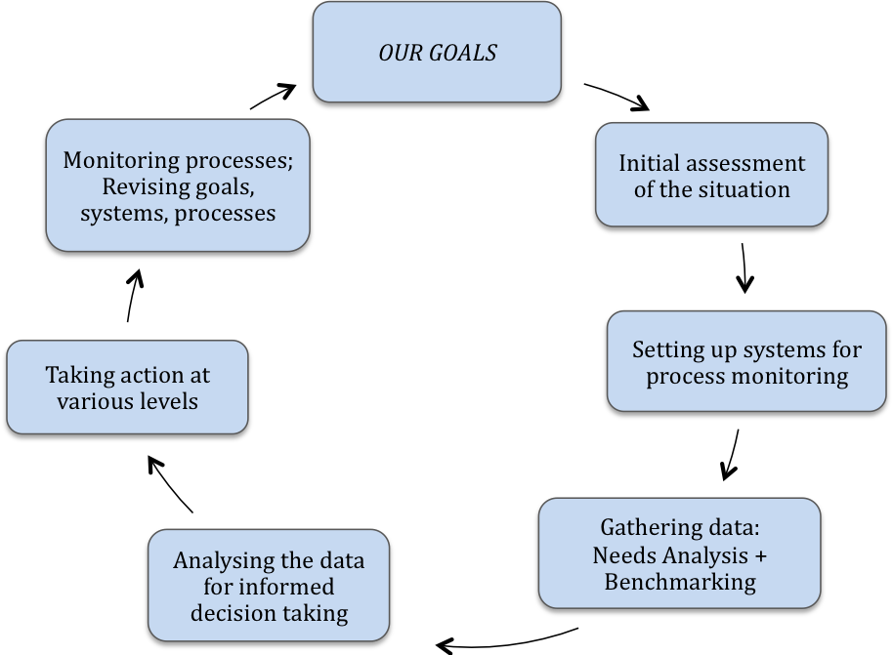

"Stages and processes in a quality cycle" - adapted from: QualiTraining (Muresan, 2007)

Examples of challenges and opportunities

A rough 'STEP' analysis can help us with an initial assessment of the general situation and its implications for ESP in Higher Education, as suggested below. As the 'bad news' are already well known and debated in both economic and academic contexts, we shall start by giving some examples of 'good news':
S – social environment: the good news is that there is a growing need for English for multiple reasons (for employability, for international mobility, for life-long learning, for post-graduate studies, etc.)
T – technology: the good news is that there is a whole range of opportunities for education, including web-based e-learning and e-teaching and e-conferencing tools and possibilities, the not so good news is that teachers need new sets of skills in order to facilitate learning through the new media;
E – economic factors: the financial crisis, downsizing in all domains, etc. What does this entail, on the competencies side, from an ESP perspective? An acute need for refined linguistic competencies and critical reading skills for on-going updating, not just regarding the latest details, but also for reading between the lines to identify trends and strategic developments in various domains, in various parts of the world. At the same time, there is an even greater need for complex and sophisticated communication skills, for work in interdisciplinary teams, for international co-operation, to name just some of the aspects to be considered.
P – political context: pre-election ‘fluidity’, accompanied by a whole range of opportunities at local / national / regional / European / international levels, through the more and more diversified contexts of possible exchanges in all spheres of activity.
We can, thus, notice that alongside 'bad news' there are also some positive factors which may represent opportunities for consolidating the status of ESP, for expanding and improving our activities.
If we switch the focus from the general environment to the local institutional context, to see where we stand, we may notice further challenges and opportunities:
Students continue to need English, German and other FLs at an advanced level, including transferable skills for employability, international mobility, to pass internationally recognised exams, etc.; but, at the same time, despite a higher entry level, most of the student groups are mixed ability, with new types of challenges; in addition, as students start work, there is also a higher degree of absenteeism.
On the teaching side (in the Business English and German Department at ASE):
- Teachers have developed a high degree of expertise, alongside other personal qualities, such as motivation;
- at team level, there is teacher training and mentoring expertise, consolidated through participation in joint teacher development programmes and a positive, collegiate atmosphere;
- there is an increasing variety of relevant and attractive teaching resources, aiming to facilitate the development of integrated skills.
Institutionally, there are signs and signals that there are fewer resources available, and this might influence the number of classes (i.e. contact hours), among other things. On the other hand, considering the challenges and opportunities at macro level, there is scope for (re-)formulating the language policy at institutional level.
Considering all these, what can we do at departmental level, so as to contribute to the (re)formulation of the institutional language policy? What can we do to enhance existing and evolving opportunities? How can we ensure a coherent and consistent approach to educational processes and to quality enhancement?
What could we do at team level?
To start with, we would definitely need to re-visit our vision and our goals, to re-adjust our benchmarks and to re-activate internal systems for monitoring processes and outcomes.
Here are a few thoughts regarding what we could do at team level:
- to take a holistic approach to language knowledge, teaching and learning, skills development, assessment, etc.;
- to carry out needs analysis, e.g. based on end-of-year test results;
- building on expertise we have in the Department, to evaluate the situation in terms of the students' language level and to come with concrete proposals regarding the desired and attainable exit level, taking into account variations in entry levels;
In terms of benchmarking, we would need to investigate and find out what others do, esp. other universities and other ESP departments in our national context. This would involve finding out about their language policy, e.g. do they have one? How is it formulated? What quality assurance systems and procedures do they have in place? How do they integrate European concepts and self-assessment instruments (Council of Europe, 2001; EAQUALS-ALTE, 2000) in the formulation of language level and communication competence requirements?
Through international benchmarking, we could draw parallels with other ESP, EAP and CLIL contexts in countries such as Norway, Finland, The Netherlands, France (Räisänen and Fortanet-Gomez, 2008)
At the same time, it would be important to create more opportunities for sharing experience and information gathered through participation in national and international projects and conferences.
To consolidate quality culture in the department, we would need to re-kindle distributed leadership (Rose, 2007). e.g.
- by taking a collective approach to problem solving, programme design and process monitoring
- through team-consultations and self-evaluation exercises at team level
- consolidating our professional status and giving more visibility to our activities, so as to have a stronger voice in the institutional decision-taking process
- by sharing examples of best practice and capitalising more on existing expertise, especially in the field of teacher training and development, quality assurance, research methodology (Bardi, 2007), with a focus on improving educational processes.

By way of a conclusion

This type of approach would benefit students and teachers alike, by contributing both to a more coherent quality management and professional growth for everyone involved. By way of a conclusion, the "fountain-tree" diagram above illustrates in a nutshell the necessary ingredients and aspects to be taken into account from a 'learning organisation' perspective. As most of these are present in the Business English and German Department, it is only a matter of putting them in relation with each other for redefining goals and refining quality management systems and processes.

REFERENCES
Bardi, Mirela, Integrating Practice and Research: Methodology and Instruments, MA course material (internal distribution for the students in the Interdisciplinary Research and Teacher Education Master at ASE Bucuresti), 2007/2008.
Council of Europe, Common European Framework of Reference for Languages: Learning, Teaching, Assessment, Cambridge: Cambridge University Press & Council of Europe, 2001.
Dressen-Hamouda, Dacia, "Aligning EAP writing pedagogies across European universities: A case study from France", in Fortanet-Gomez Inmaculada and Christine Räisänen (Eds), 2008.
EAQUALS and ALTE, The EAQUALS-ALTE European Language Portfolio. Milano: Lang Edizzioni, 2000; on-line version available at www.eELP.org.
Hellekjaer, Glenn Ole, "Quality Issues in English-Medium Instruction: Norwegian Students' Aural and Oral Proficiency in Non-elective Courses", presentation at the 15th World Congress of Applied Linguistics - AILA 2008: Multilingualism: Challenges and Opportunities, Essen, 24-29 August 2008.
Muresan, Laura, "Systems, processes and instruments for quality management", in Muresan, Laura, Frank Heyworth, Galya Mateva and Mary Rose, 2007.
Muresan, Laura, Frank Heyworth, Galya Mateva and Mary Rose, QualiTraining - A Training Guide for Quality Assurance, Strasbourg: Council of Europe Publishing, 2007 (on-line version at: www.ecml.at).
Pedler, M., J. Burgoyne, and T. Boydell, The learning company, Maidenhead, McGraw-Hill, 1997.
Räisänen, Christine and Inmaculada Fortanet-Gomez, "The State of ESP Teaching and Learning in Western European Higher Education after Bologna" in Fortanet-Gomez Inmaculada and Christine Räisänen (Eds), ESP in Higher Education, Amsterdam/Philadelphia: John Benjamins Publishing, 2008.
Räsänen, Anne, "Evaluating Content and Language Integrated Programmes in HE", presentation at the 15th World Congress of Applied Linguistics - AILA 2008: Multilingualism: Challenges and Opportunities, Essen, 24-29 August 2008.
Rose, Mary, "Quality and People" in Muresan, Laura, Frank Heyworth, Galya Mateva and Mary Rose, 2007.
Walker, Martin, "Silver Lining - how the economic crisis can make us healthier, wealthier & wiser", in The American Interest, vol. IV, No 4, March-April 2009 (pp. 6 - 12).

