FOR THE TEACHER
Lost dog
Type of task: Project

Educational level: Primary/secondary education - ISCED 1/2

Proficiency level: A2

Short description and aim of the activity:
The aim of this activity is to practise specific vocabulary, introduce students to different text media, and raise intercultural awareness. Students read a short text in Language A about a friend’s missing dog, and they will have to create an Instagram post and a “lost dog” flyer in Language B.

Background information
A revision of the names of colours and animal features is advisable.
CEFR mediation scale and descriptor (to which the activity refers):
PROCESSING TEXT IN WRITING
- Can use simple language to render (in Language B) very short texts written in (Language A) on familiar and everyday themes that contain highest frequency vocabulary; despite errors, the text remains comprehensible. Can copy out short texts in printed or clearly hand-written format.

CEFR mediation strategies involved
ADAPTING LANGUAGE
- Can repeat the main point of a simple message on an everyday subject, using different words to help someone else understand it.
STREAMLINING A TEXT
- Can identify and mark (e.g., underline, highlight etc.) the key sentences in a short, everyday text.

Languages involved (Language A –Language B – Language C)
This task includes multiple versions, depending on the languages involved:
- Version 1: Language A (Greek) – Language B (English)
- Version 2: Language A (Greek) - Language B (French)
- Version 3: Language A (Greek) - Language B (Estonian)
- Version 4: Language A (Greek) - Language B (Swedish)
- Version 5: Language A (Greek) - Language B (German)
- Version 6: Language A (Greek) - Language B (Polish)

- Version 7: Language A (Finnish) - Language B (French)
- Version 8: Language A (Finnish) - Language B (Estonian)
- Version 9: Language A (Finnish) – Language B (English)
- Version 10: Language A (Finnish) - Language B (German)
- Version 11: Language A (Finnish) - Language B (Swedish)
- Version 12: Language A (Finnish) - Language B (Polish)

- Version 13: Language A (English) - Language B (Swedish)
- Version 14: Language A (English) -Language B (French)
- Version 15: Language A (English) -Language B(Estonian)
- Version 16: Language A (English) - Language B (German)
- Version 17: Language A (English) - Language B (Polish)

- Version 18: Language A (French)- Language B (English)
- Version 19: Language A (French)- Language B (Estonian)
- Version 20: Language A (French) - Language B (Swedish)
- Version 21: Language A (French) - Language B (German)
- Version 22: Language A (French) - Language B (Polish)

- Version 23: Language A (Estonian)- Language B (English)
- Version 24: Language A(Estonian) - Language B (French)
- Version 25: Language A (Estonian) - Language B (Swedish)
- Version 26: Language A (Estonian) - Language B (German)
- Version 27: Language A (Estonian) - Language B (Polish)

- Version 28: Language A (Swedish) - Language B (English)
- Version 29: Language A (Swedish) - Language B (French)
- Version 30: Language A (Swedish) - Language B (Estonian)
- Version 31: Language A (Swedish) - Language B (German)
- Version 32: Language A (Swedish) - Language B (Polish)

- Version 33: Language A (German) - Language B (English)
- Version 34: Language A (German) - Language B (Swedish)
- Version 35: Language A (German) - Language B (Estonian)
- Version 36: Language A (German) - Language B (French)
- Version 37: Language A (German) - Language B (Polish)

- Version 38: Language A (Polish) - Language B (Swedish)
- Version 39: Language A (Polish) - Language B (German)
- Version 40: Language A (Polish) - Language B (French)
- Version 41: Language A (Polish) - Language B (Estonian)
- Version 42: Language A (Polish) - Language B (English)
* This activity could also be adapted for Languages A-B-C

Linguistic objectives. Students will be able to:
- remember and use words related to the topic of pets (e.g., body parts, colours, etc.)
- mediate the same information in different types of text types (such as flyers and online posts).

Other competences involved:
- Media and information literacy: analyse and evaluate media content
- Interpersonal skills: teamwork
- Critical thinking: reflective thinking, reasoned decision making

Time/lessons needed for the activity: 45 minutes

Resources required:
The teacher can print all the handouts in advance.
Procedure:

 |  | Class organisation | Ideas for differentiation
Step 1 | Firstly, the teacher asks the students if they have pets. Some questions could be:  - Do you have a pet?  - If you don’t have one, what pet would you like to have?  - Tell me some words you know in LB about pets.  - What activities could/do you do with your pets? | plenary | This activity could be also a group activity or a Padlet/Flinga activity in case the teacher has to teach online.
Step 2 | Then, the teacher shares Handout A with the students, and asks them to first match the phrases with the photos, and then to tick five activities that they would like to do with their pets. | pairs | If students are not familiar with this vocabulary, they could use a dictionary.
Step 3 | After the activity, the teacher discusses what information someone creating a missing dog flyer should share. (The teacher can draw a template on the whiteboard so the students can add the information or use Handout C for this purpose.) | groups
Step 2 | Then, the teacher can ask what would be different if someone decided to post a photo of their missing dog on social media. The students then could discuss what information is appropriate/advisable to share. | groups
Step 3 | The teacher introduces the lost dog flyer and Instagram templates (Handout C/D). | plenary
Step 4 | The students read Handout B (lost dog message) and work in pairs and create their own flyer and Instagram post based on the given scenario. | pairs | They could use the photo of Handout 3 to glue/copy-paste it into the Instagram post.
Step 5 | When the students are ready, they could compare their flyers and/or even display them on the wall. | pairs | In case this is an online lesson, the students could post the photos in Teams or Padlet.
Step 6 | The teacher asks questions at the end of the lesson to raise cultural awareness. For example:  - How often do you see a flyer nowadays?  - Why do you think this happens?  - Which one of the two options would you choose?  - Which one is safer?  - Has something similar happened in your family?  - Did you have a similar occasion where you helped someone who couldn't understand specific information because of the language they speak? | plenary
Step 7 | For additional practice, they could create a flyer/Instagram post about their missing imaginary pet as part of their homework. | individual | writing activity

Extra resources and/or tips for the teacher
Teachers might want to make the activity more culture-specific and introduce, for example, a different dog breed common to the area where the students live, or the country the teacher would like to study with their students.
Suggestions and ideas for adapting/differentiating for different contexts
- All users of social media applications should be 13+. Thus, using the actual application is not recommended.
- This activity can be adapted by using Language A-B-C depending on your context. The students could read Handout A (Love your pet day) in Language C but communicate in class in Language A and B, or write the Instagram post and/or flyer of this activity (Handouts C/D) in Language C instead of B.
- If the teacher is running out of time, they might need to use two lessons in order to complete both parts of this task or assign one of the two activities as homework (Handouts C/D).

ACTIVITY WORKSHEET
Lost dog
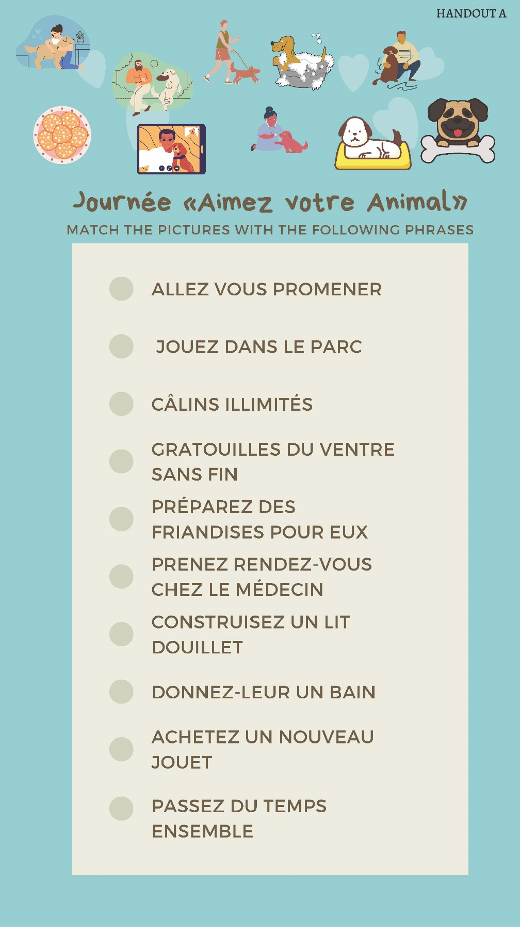

International Standard Classification of Education (ISCED) - Statistics Explained (europa.eu)
The METLA team would like to thank the translators for their dedication and hard work! - French translator: Helena Eijsberg - German translator: Katrin Korkalainen - Swedish translator: Michael Persson - Estonian translator: Kristin Kõiv - Polish translator: NataliaKardasz - Finnish translators: Hanne Haapakoski/Ville Kaksonen

