FOR THE TEACHER
First-aid instructions

Type of task: role play

Educational level: secondary education - ISCED 2/3
Proficiency level: B2 Level

Short description and aim of the activity
The aim of this activity is to practise student’s reception and production skills in an authentic situation. Students first read a short text tin Language A about fainting, and then role play a phone call scenario in pairs.

Background information (if applicable):
The teacher could introduce a short revision of the vocabulary related to symptoms and treatments as a warm-up activity.

CEFR mediation scale and descriptor (to which the activity refers):
Processing text in speech
- Can summarise (in Language B) the important points made in longer, spoken and written complex texts (in Language A) on subjects of current interest, including his/her fields of special interest.

CEFR mediation strategies involved
ADAPTING LANGUAGE:
- Can explain technical topics within his/her field, using suitably non-technical language for a listener who does not have specialist knowledge.
- Can make a specific, complex piece of information in his/her field clearer and more explicit for others by paraphrasing it in simpler language.
- Can make accessible for others the main contents of a spoken or written text on a subject of interest (e.g., an essay, a forum discussion, a presentation) by paraphrasing in simpler language.

BREAKING DOWN COMPLICATED INFORMATION
- Can make a complicated issue easier to understand by presenting the components of the argument separately.
- Can make a complicated process easier to understand by breaking it down into a series of smaller steps.
STREAMLINING A TEXT
- Can simplify a source text by excluding non-relevant or repetitive information and taking into consideration the intended audience.
- Can edit a source text by deleting the parts that do not add new information that is relevant for a given audience in order to make the significant content more accessible for them.
- Can identify related or repeated information in different parts of a text and merge it in order to make the essential message clearer.

Languages involved (Language A –Language B – Language C)
- Language A (Finnish) – Language B (English)
- Language A(Greek) – Language B (English)
* This activity could also be adapted for Languages A-B-C

Linguistic objectives. Students will be able to:
- recall and use vocabulary related to diseases.
- Summarise orally (in Language B) the main points made in straightforward informational written texts (in Language A).

Other competencies involved:
Inter-personal skills: teamwork, empathy, and compassion

Time/lessons needed for the activity: 30 minutes

Resources required
A copy of Handouts A and B for each pair or group.
Procedure:

 |  | Class organisation | Ideas for differentiation
Step 1 | Warm up: The teacher asks questions to set the scene, e.g.  - Have you ever taken a first aid class, or seen what to do in a medical emergency on TV or in a film?  - Have you ever been with someone who had an accident or needed help?  - What do you think would be important to do to help someone in a medical emergency?  Inform students they are going to do a role-play activity about helping someone deal with a common medical emergency: fainting. They will first read a text and do some exercises, and then proceed to the role play.  The teacher separates the students into pairs and gives each pair Handout A (First Aid: Fainting). | pairs | The teacher can choose a different medical topic related to the other courses the students are taking (e.g., biology, a First Aid seminar, health class etc).
Step 2 | In pairs, students read the text in Language A and complete the exercises.  The teacher checks the answers in a plenary. | pairs / plenary
Step 3 | The teacher gives students their portion of Handout 2(containing the role play instructions for roles A and B). In groups of four, the students prepare their parts. The two As prepare their parts together, and the two Bs prepare theirs. Then, each of the As interacts separately with their B counterpart. | groups | If some of the students do not feel very confident, they could also use a dictionary.
Step 4 | The students act out the role play in pairs | pairs

Extra resources and/or tips for the teacher
- If the teachers use the recorded version of the activity, they could give informal feedback to the students individually, and some examples for a more effective performance.
Suggestions and ideas for adapting/differentiating for different contexts
- This activity can be adapted by using Languages A-B-C, depending on your context. For example, the students could read Handout 1 (First Aid: Fainting) in language C, communicate in class in Language A, and then practise the dialogue in Language B.
- This activity could become part of wider project integrated with other subjects, e.g., health class, biology.

FOR THE STUDENT: ACTIVITY WORKSHEET
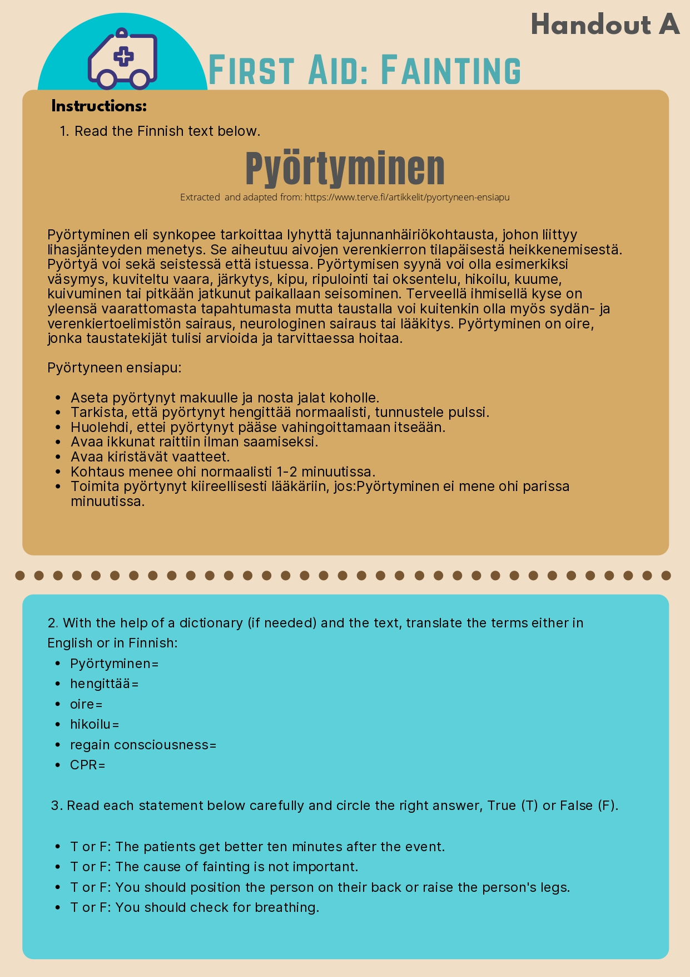
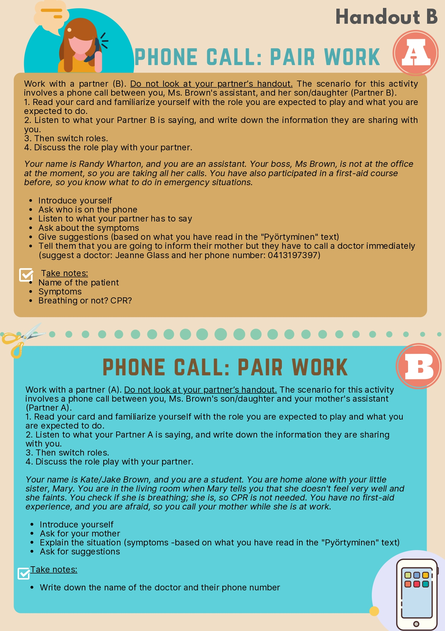

International Standard Classification of Education (ISCED) - Statistics Explained (europa.eu)

