FOR THE TEACHER
Student-teacher E-communication
Type of task: project (on email writing)
Educational level: Secondary education - ISCED 2/3
Proficiency level: B2 Level
Short description and aim of the activity:
This is a project activity that focuses on email communication between students and teachers. The duration of the project is two lessons. There are eight distinct steps in this project. The aim of this activity is to familiarise the students with the style of email communication in general, and raise awareness of intercultural communication in particular.

Background information (if applicable):

CEFR mediation scale and descriptor (to which the activity refers):
Relaying specific information in writing
- Can relay in writing the significant point(s) contained in formal
correspondence (written in Language A).

CEFR mediation strategies involved:
LINKING TO PREVIOUS KNOWLEDGE:
- Can clearly explain the connections between the goals of the session and the personal or professional interests and experiences of the participant(s).
- Can formulate questions and give feedback to encourage people to make connections to previous knowledge and experiences.
- Can explain a new concept or procedure by comparing and contrasting it to one that people are already familiar with.
STREAMLINING A TEXT
- Can simplify a source text by excluding non-relevant or repetitive information and taking into consideration the intended audience.
- Can edit a source text by deleting the parts that do not add new information that is relevant for a given audience in order to make the significant content more accessible for them.
- Can identify related or repeated information in different parts of a text and merge it in order to make the essential message clearer.

Languages involved (Language A –Language B – Language C):
This task includes four versions depending on the languages involved:
- Version 1: Language A (Finnish) – Language B (English)
- Version 2: Language A (Greek) – Language B (English)
- Version 3: Language A (English) – Language B (Greek)
- Version 4: Language A (English) – Language B (Finnish)
- This activity could also be adapted for Languages A-B-C.

Linguistic objectives. Students will be able to:
- analyse various examples of online communication (such as emails and text messages).
- write an email addressed to their teachers.
- evaluate their email production performance

Other competencies involved:
- Critical thinking: reflective thinking, reasoned decision making
- Global citizenship: respect for diversity, intercultural understanding
- Media literacy: analyse media content
- Interpersonal skills: teamwork

Time/lessons needed for the activity: 2 lessons

Resources required:
A copy of the five Handouts A-E will be needed for each student or group, depending on the Step, as described below.
Procedure:
 |  | Class organisation | Ideas for differentiation
Step 1 | The teacher separates the students into small groups and gives them Handout A. This is a warm-up activity for students to familiarise themselves with different parts of an email. (10-15 min) | groups
Step 2 | In the same groups, the students receive the Handout B. This is a brainstorming task; the students have to decide on what makes an informative email. (10 -15 min) | groups | If this activity is carried out online, a forum or Zoom breakout rooms could be used as a way to form group answers.
Step 3 | The students have to write all the words/ concepts they have come up with on the whiteboard. (10 min) | plenary | In an online environment, the teacher could either use a Forum/ Flinga/ Padlet to correct all the students’ answers
Step 4 | The teacher then has to read the responses and negotiate with the students about which are the most important ones and underline them. These can then become the students' guidelines/criteria for a successful email (in Step 6). (5-10 min).  At the end of the first lesson, the teacher will need to take a photo of the content on the white board and recreate the students’ answers next time. | plenary
Step 5 | The students will receive Handout C (three pages), including different examples in Language A and Language B. Based on their answers in Step 4, they will have to grade the emails and provide a justification for their grade. (15 min) | group work | In case this is an online lesson, this step could be given for homework.
Step 6 | The students will have to write an email to their teacher based on a scenario given in Language A on Handout D (2-pages). (20 min) | individual | In an online lesson, this could be a great pair activity. The students then could practise how to write emails in an authentic environment. To conclude, they could send the activity to their teacher via email.
Step 7 | The students have to check the self-assessment list (Handout E) and decide if they have written their email according to it. (5 min) | individual
Step 8 | Finally, the students have to pass their email and assessment list to their partner so they can discuss their performance together. (5-10 min) | pairs | Online lesson: The teacher could post all their answers to a forum/Padlet/Flinga anonymously and ask the students to grade and provide a justification (what worked well/things the writer could develop) and post their answer under the email examples.

Extra resources and/or tips for the teacher
The teacher should think not only of the vocabulary of the languages involved, but also the style and register, in other words, the way we compose an email in Language A and Language B when creating the activity, e.g.
- Style:
- How familiar are the students with emails in general?
- What is the appropriate level of formality when you are writing an email to your teacher in Language A and Language B?
- What are the appropriate expressions which are used in an email in Language A and Language B?
There were no significant differences in the style of the emails when Greek was used as Language A and English as Language B. However, when Finnish was used as Language A, more emphasis was needed on the style, and specifically on the appropriate level of formality between Language A (Finnish) and Language B (English).
For example, the general greetings used in the Finnish emails are only the words, “Hei” or “Moi” both meaning “hi”, instead of “dear Ms Hardie” (the surname of the recipient). This is a clear example of cultural differences and an example that could be used in class to promote cultural awareness.
Another example is the way students address their teachers in Finland. They call their teachers with their first names from the kindergarten onwards, e.g., “Hey (Hi) Neea”, and this could also sound rude in English.
Thus, when a teacher notices these kinds of differences between Language A and B, they should take some time and emphasise the Language B email etiquette, in this case, English, during the time the students are creating the criteria of a good email (Step 4).
Suggestions and ideas for adapting/differentiating for different contexts:
- This activity can be adapted by using Language A-B-C, depending on your context. The students could provide an answer in Language C instead of A or B. Steps 2, 4, 6 could be easily adjusted in order to include Language C. For example, the teacher could allow Language B and C notes in the brainstorm activity, the examples of emails could be in Language A/B/C, and another text message from a student in Language C could be given to a student in order to write an email to the teacher.
FOR THE STUDENT: ACTIVITY WORKSHEET
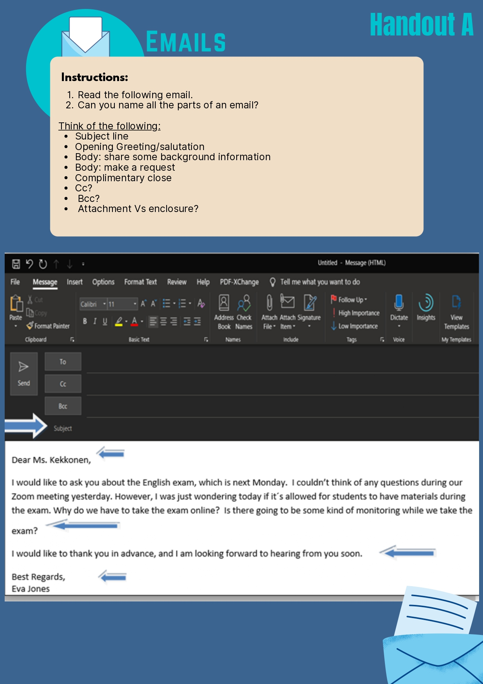

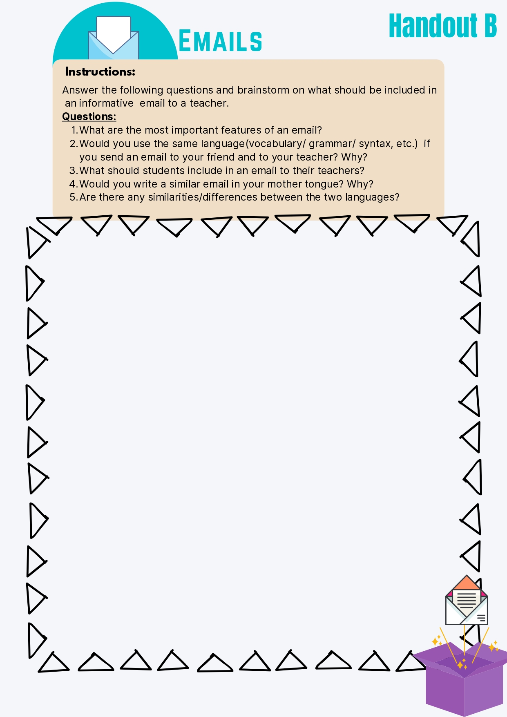

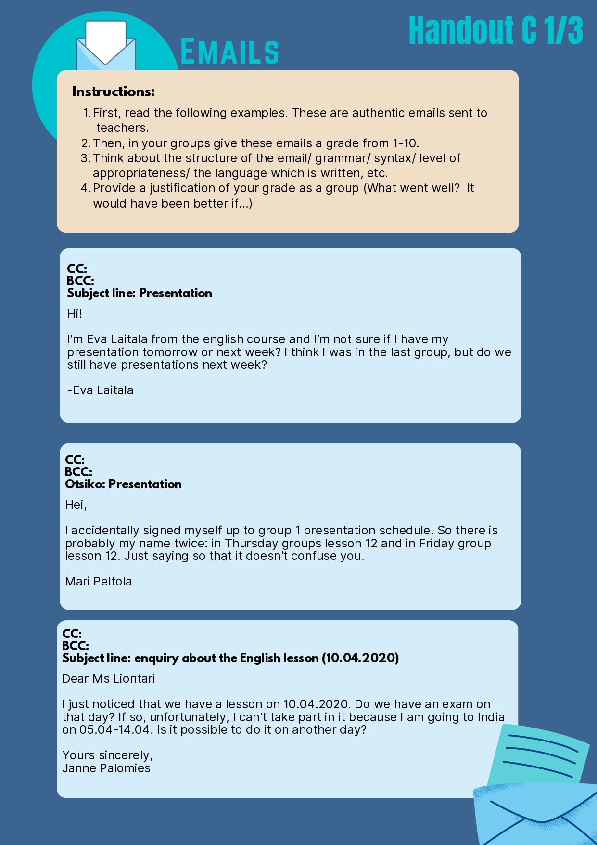

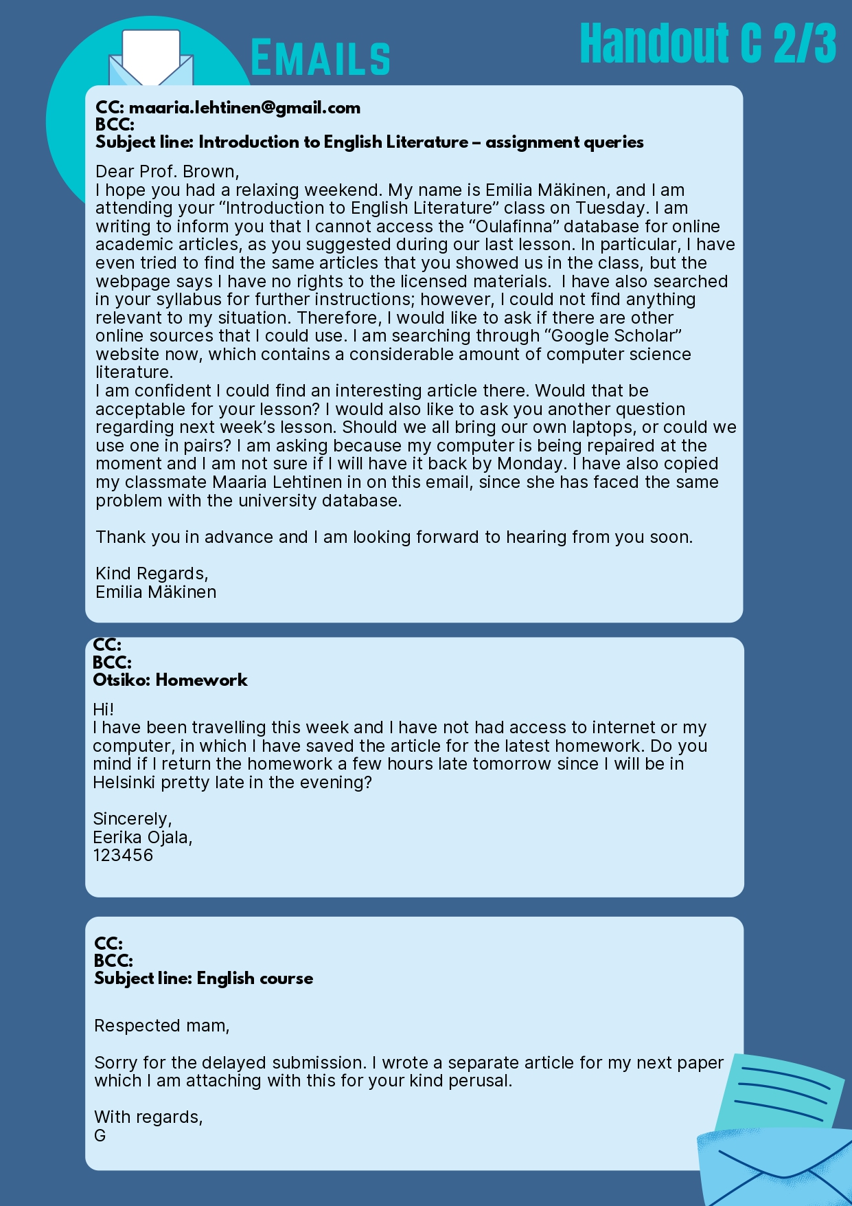

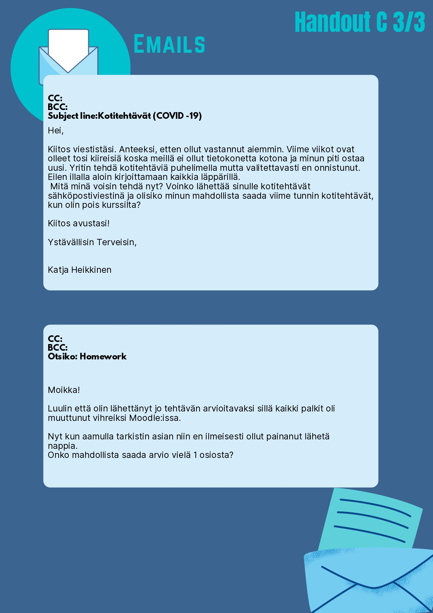

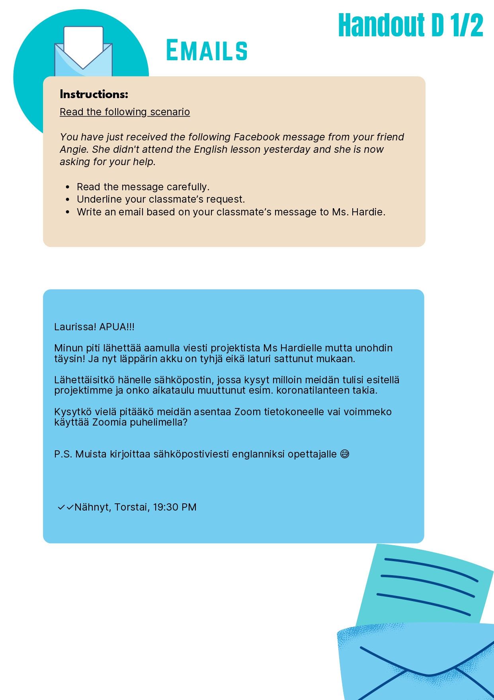

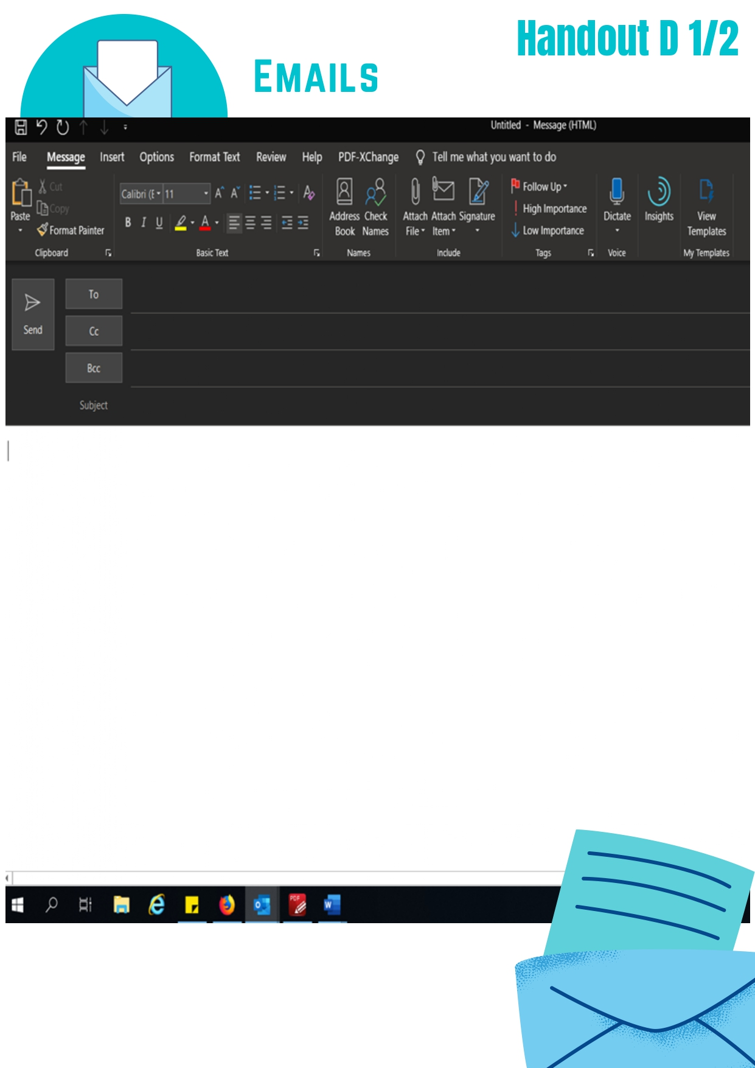
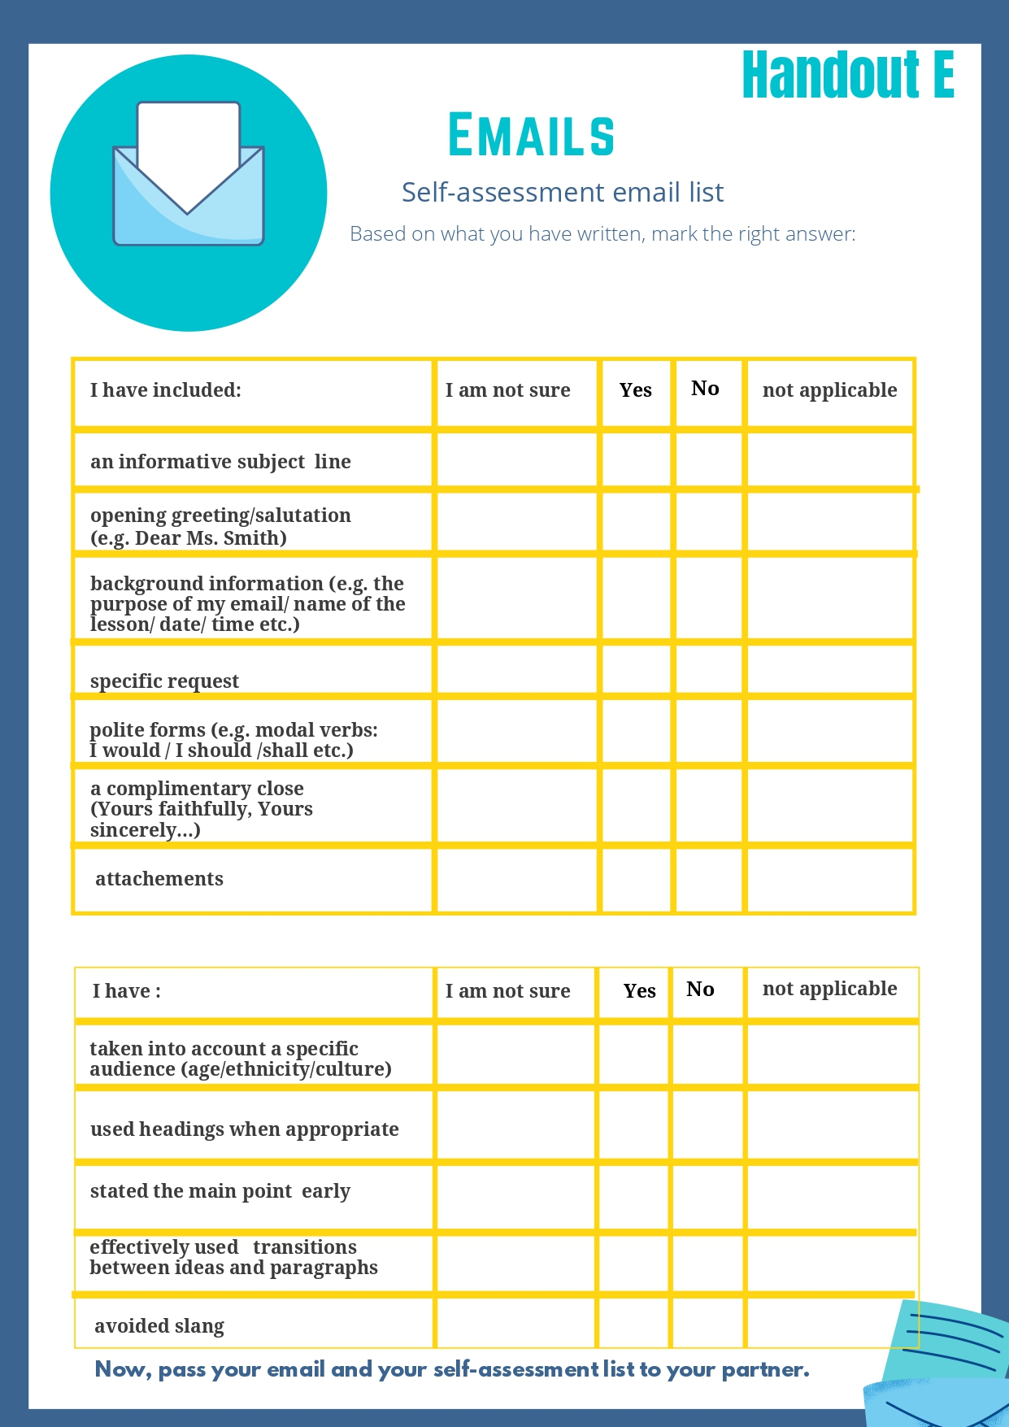

International Standard Classification of Education (ISCED) - Statistics Explained (europa.eu)

