FOR THE TEACHER
Airport instructions
Type of task: Giving instructions in text messages and emails

Educational level: Secondary education - ISCED 2/3

Proficiency level: B1 Level

Short description and aim of the activity:
This is a project activity that focuses on cross-cultural communication and the way we communicate parts of this information to different people. First, the students will read a text regarding airport transportation, and they will write informal short messages as part of written text communication with an exchange student. Then, the students will have to use the same information and write a formal email to the student’s parents.

CEFR mediation scale and descriptor (to which the activity refers):
Relaying specific information in writing
- Can relay in writing (in Language B) specific information points contained in texts (spoken in Language A) on familiar subjects (e.g. announcements, and instructions).

CEFR mediation strategies involved:
LINKING TO PREVIOUS KNOWLEDGE
- Can explain how something works by providing examples which draw upon people’s everyday experiences.
- Can show how new information is related to what people are familiar with by asking simple questions.
BREAKING DOWN COMPLICATED INFORMATION
- Can make a short instructional or informational text easier to understand by presenting it as a list of separate points.
ADAPTING LANGUAGE
- Can paraphrase more simply the main points made in short, straightforward spoken or written texts on familiar subjects (e.g. short magazine articles, interviews) to make the contents accessible for others.
STREAMLINING A TEXT
- Can identify and mark (e.g. underline, highlight etc.) the essential information in a straightforward, informational text, in order to pass this information on to someone else.

Languages involved (Language A –Language B – Language C):
This activity includes two versions, depending on the languages involved:
- Version 1: Language A (Finnish) – Language B (English)
- Version 2: Language A (Greek) – Language B (English).
Note: The activity could also be adapted for Languages A-B-C
Linguistic objectives. Student will be able to:
- summarize information from Language A to Language B.
- write informal text (SMS)messages in Language B.
- write a formal email about the same subject in Language B.
- evaluate their performance on text production (i.e., their text messages and emails).

Other competences involved:
- Global citizenship: intercultural understanding
- Critical thinking: reflective thinking
- Media and Information literacy: the ability to locate and access information

Time/lessons needed for the activity: 1-2 lessons

Resources required:
Copies of the handouts, which could be printed (or the instructions shared via email) in advance.

Extra resources and/or tips for the teacher
The students need to be familiar with different styles of various written texts (genres), e.g. informal text messages between students, formal email to a parent etc.

Procedure:
 |  | Class organisation | Ideas for differentiation
Step 1 | The teacher starts with a warm-up focusing on travelling abroad.  The class is split into groups and asked to write down all the words they know about travelling and airports.  Then, they discuss what they have written in class (Language A or B).  Examples of questions could be:  - Name all the words you can think of related to travelling and airports.  - Have you ever travelled abroad?  - What do you need in order to be able to travel abroad?  - Which country would you like to visit?  - What language do people speak in that country? | groups/  plenary | In this warm-up, teachers can decide, based on students’ language skills, whether the students will produce their answers in Language A/ B/both.
Step 2 | The teacher explains that the main topic will be based on the Airport leaflet Handout A (Airport leaflet_ Language A). Then, the teacher gives the leaflet to the students and asks them to read it. | pairs | The Handout A information (airport leaflet) was extracted from the official website of the airport. In case, you are adapting this activity in another language you should visit the official website of the airport you find relevant to your context and use this information.  If the students don’t know much about their country’s main airport since they stay in a different part of the country, the teacher could tell them more. In order to find this activity relevant, the teacher could also explain that the main airport is one of the main ways for an exchange student to reach their country.
Step 3 | Then, the teacher shares Handouts B1/2 and B 2/2 with the students, who read the following scenario: “Eve, an exchange student from England, is coming to your school for a semester. You had met Eve during a previous project, and you became friends. For that reason, your family suggested that she could stay in your home. However, you cannot pick her up from the airport. Text Eve and help her find her way safely to Athens based on the Airport leaflet you have. Complete the dialogue.” Students read the Airport instructions first (Language A), and then complete the written text dialogue activity based on Handout A in Language B (15 minutes). | pairs
Step 4 | The teacher checks the answers to the dialogue activity in the class and discusses the different variations the students have created. | plenary
Step 5 | Finally, the students write an email to Eve’s parent (Handout C) based on the information selected from the Handouts A and B (20 minutes). Instructions: “Based on the messages you have exchanged with Eve and the information you have from the Airport leaflet, write an email to Eve's mother, Mary Brown. Introduce yourself, inform her about the situation and what you have agreed with Eve, and give your parents' details (names and phone numbers).” | individual | This could also be used as homework (revision) if the students have already practised email writing before.  If the students are not familiar with e-mails, then this activity could be used as an introduction of email writing. In that case, the teacher could use another lesson to introduce this activity and explain the language and structure of an email.
Step 6 | Finally, the teacher shares Handout D- the Self-assessment task “Reflection” -with the students. Students answer the Self-assessment form (10 min).  You could start a discussion based on the content of the self-assessment form. | individual

Further tips and guidance:

Think of the following questions before you introduce this activity to the students:

- What is the appropriate level of formality when you exchange text messages with a classmate and, when you write an email to a parent in Language A and Language B?
- How familiar are the students with emails in general?
- What are the appropriate expressions used in an email in Language A and Language B?

Based on your answers, you might need to adapt some parts of this activity or explain/practise in advance, for example, how to write an e-mail in Language B.

Suggestions and ideas for adapting/differentiating for different contexts
- The information of Handout A (airport leaflet) was extracted from the official website of an airport. If you are adapting this activity for another language, you should visit the official website of the airport you find relevant to your context and use that information.
- This activity can be adapted by using Language A-B-C, depending on your context. The students could read Handout B (the airport leaflet) in language C, but communicate in class in Language A and B, or write the email part of this activity (Handout C) in Language C instead of B.
- If the students find the email part of this activity (Handout C) challenging or you are running out of time, you might need to use two lessons in order to complete both parts of this activity.
- Due to the Covid-19 pandemic, many classes are taught online. In that case, the use of a Forum or online emails is recommended in order for students to complete the activity in Handout C.

FOR THE STUDENT: ACTIVITY WORKSHEET
Airport instructions
Information extracted from https://www.aia.gr/traveler/access-and-transportation/transportation/public-transportation (accessed on 09 August 2023)

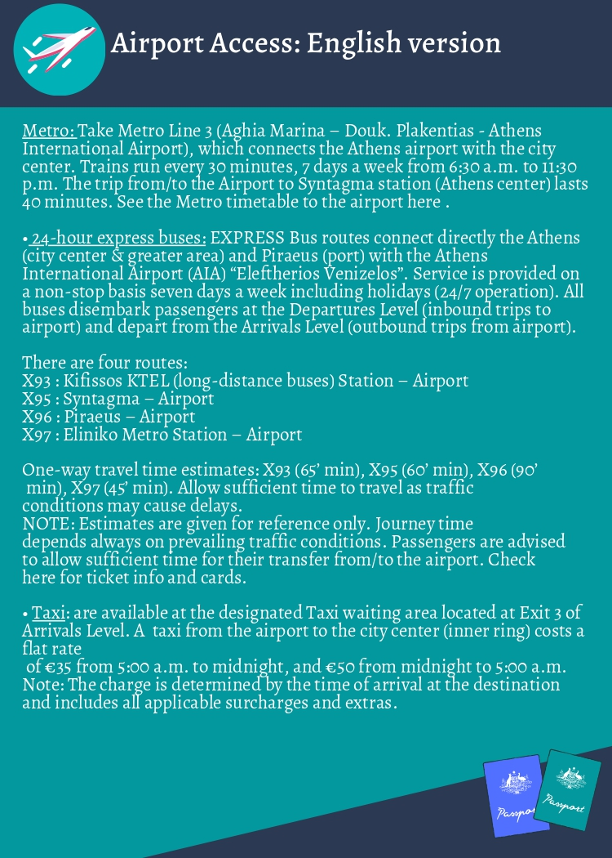

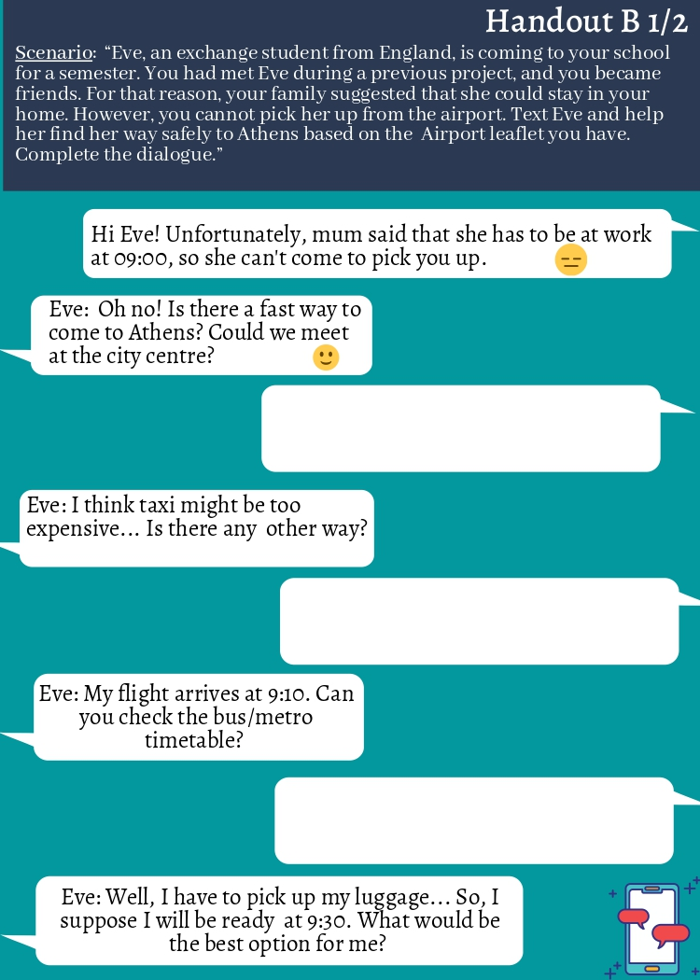

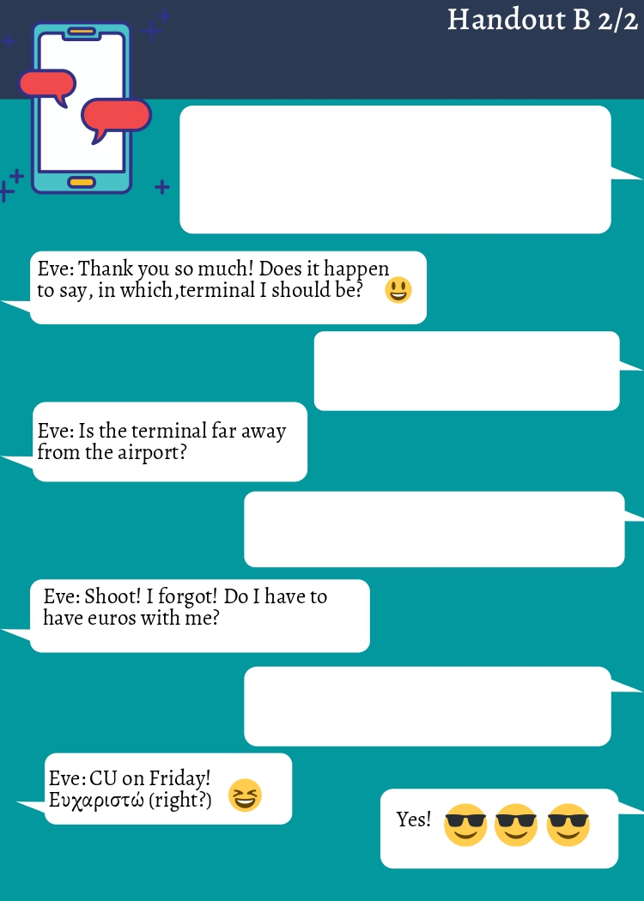

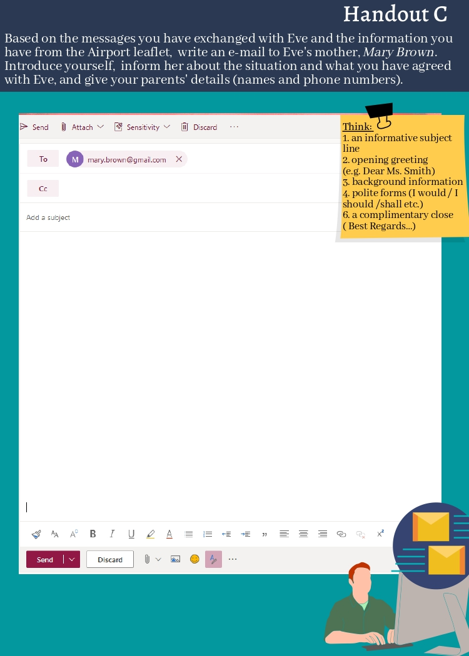

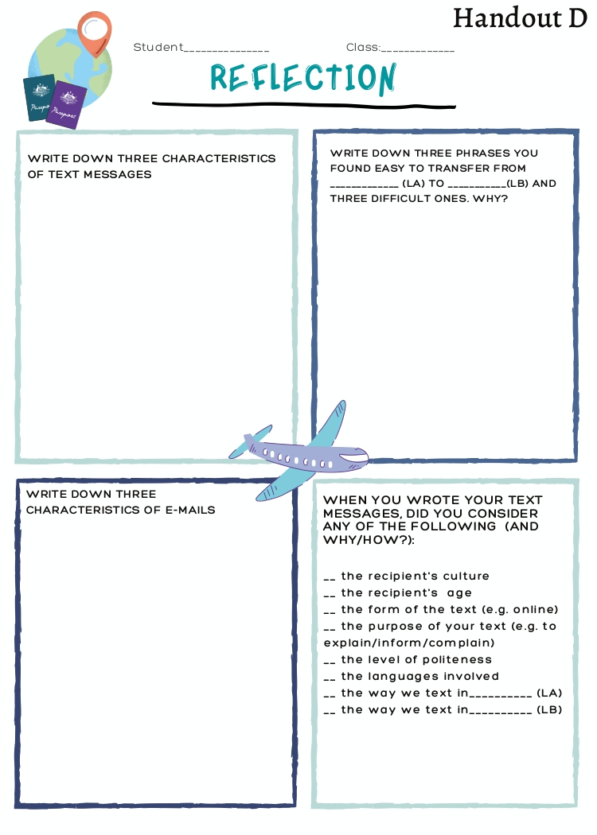

International Standard Classification of Education (ISCED) - Statistics Explained (europa.eu)

