***FOR THE TEACHER***

**Proper use of face masks**

**Type of task**: Relaying and translating information from a poster

**Educational level**: Primary/ secondary education - ISCED 1/2[1]

**Proficiency level:** A2-B1

**Short description and aim of the activity**: Students are expected to relay information and explain data about the correct use of face masks with the help of poster diagrams, and also to produce an approximate translation.

**Background information:**

During the pandemic that hit the world in 2020, countries faced challenges in providing their citizens with access to the right information on how to mitigate the spread of the virus COVID-19. In Malta, such information was presented in the two official languages of the country, Maltese and English. Amongst the measures adopted at the time, use of face masks was mandatory in all public spaces.

**CEFR mediation scale and descriptor** (to which the activity refers):

RELAYING SPECIFIC INFORMATION IN SPEECH AND IN WRITING

* *Can relay (in Language B) specific information given in straightforward informational texts (such as leaflets, brochure entries, notices and letters or emails) (written in Language A).*

EXPLAINING DATA

* *Can interpret and describe (in Language B) simple visuals on familiar topics (with text in Language A), even though pauses, false starts and reformulation may be very evident in speech.*

TRANSLATING A WRITTEN TEXT IN WRITING

* *Can produce approximate translations (from Language A into Language B) of information contained in short, factual texts written in uncomplicated, standard language; despite errors the translation remains comprehensible.*

**CEFR mediation strategies involved:**

ADAPTING LANGUAGE:

* *Can paraphrase more simply the main points made in short, straightforward spoken or written texts on familiar subjects to make the contents accessible for others.*

STREAMLINING A TEXT

* *Can identify and mark the essential information in a straightforward, informational text, in order to pass this information to someone else.*

**Languages involved:**

Language A: Maltese

Language B: English/Any Language

**Linguistic objectives. Students will be able to:**

* use information from a text of a different genre in Language A to produce another text in Language B.
* understand the main ideas within a text.
* explain the main ideas in a text orally and in writing.
* translate information contained in a short text in Language A to Language B.

**Other competences involved**:

* interpersonal skills (communication)
* interpersonal skills (being of service to others; being socially responsible)
* making good use of a dictionary and other translation tools

**Time/lessons needed for the activity:** 1.5hours

**Resources required:**

Copies of worksheets for each student for Steps 2-4.

**Procedure**:

|  |  |  |  |
| --- | --- | --- | --- |
|  |  | Class organisation | Ideas for differentiation |
| Step 1 | Students are asked to discuss whether they have ever been asked to read or translate a text in Maltese to their home language for a relative or friend who does not speak Maltese. Was it easy for them to do so? Were there pictures or diagrams which helped them in performing the task? Was it a very important text? Were they helpful? | Plenary |  |
| Step 2 | Students are presented with the poster *Użu tajjeb tal-maskri.* After reading the information on the poster, they complete an activity in which they are to choose the best answer (A, B or C), to complete each statement. | Individual | This and other similar activities can be used to scaffold understanding in preparation for the mediation task in Step 3. |
| Step 3 | Students orally explain the content of the poster to their parent (in English or in their home language). | Individual/ Pairs | Students may wish to role-play this situation with a classmate who plays the role of the parent. |
| Step 4 | Peer Feedback– Students reflect on how successful mediation was. | Class discussion | The criteria for this evaluation could be either provided by the teacher or discussed with the students.  If nobody in class speaks the student’s home language, the mediated message can be evaluated by a family member. |
| Step 5 | Students are asked to translate the poster into their home language | Individual |  |
| Step 6 | Peer Feedback– Students reflect on how successful mediation was. | Class discussion | The criteria for this evaluation could be either provided by the teacher or discussed with students who speak the language.  If nobody in class speaks the student’s home language, the mediated message can be evaluated by a family member. |

**Extra resources for the teacher:**

A copy of the poster in English.

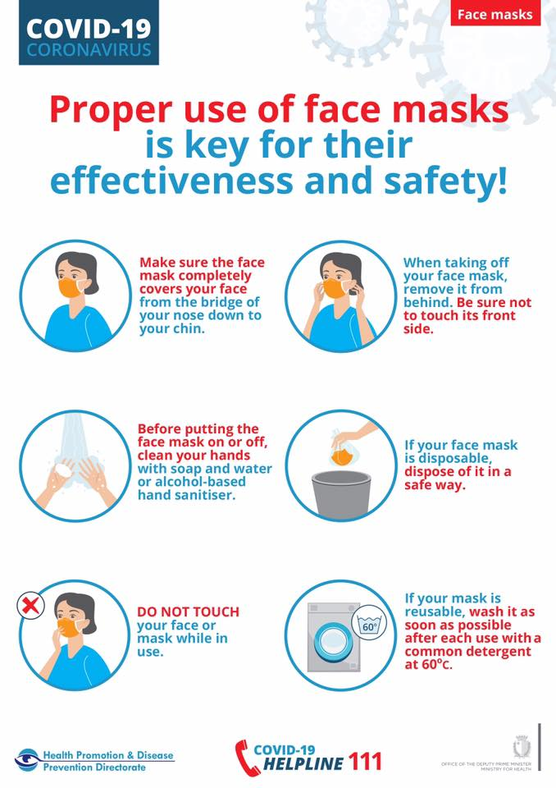

**Further tips and guidance:**

The use of dictionaries in Maltese, English and the other home languages should be allowed. Online dictionaries could also help students with accomplishing the tasks.

***FOR THE STUDENT: ACTIVITY WORKSHEET***

**Proper use of face masks**

**Step 1**

Teacher asks questions to introduce the topic and engage the students:

* *Have you ever been asked to read or translate a text from Maltese to your home language for a relative or friend who does not speak Maltese?*
* *Was it easy for you to do so?*
* *Were there pictures or diagrams which helped you in performing the task? Was it a very important text?*
* *Were you helpful?*

**Step 2**

You migrated with your parents to Malta where you have been living for the past two years. Your mum/dad does not understand any Maltese at all, but you have been learning it for the past two years and have become quite good at it. While in the waiting area of a medical clinic with your mum/dad, you see this poster about the proper use of face masks and want to tell your parents what it says.

**A. Before you start speaking, read the information on the poster carefully and then do the exercise below.**

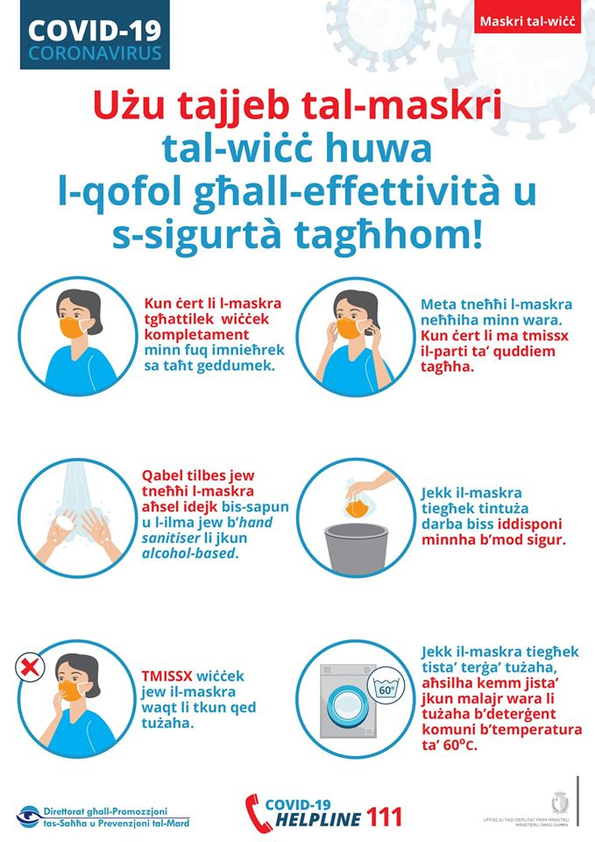



**Step 3**

Work in pairs. Student A will play the role of the parent, and Student B will explain to him/her in English or (in their home language) what the poster is saying.

**Step 4**

Imagine that you go to a multilingual school and the school principal has asked the older students to translate the content of the leaflet in as many languages as possible so that all learners, including those who do not speak Maltese yet, can understand it. The principal will then hang the translated posters on the school notice board.

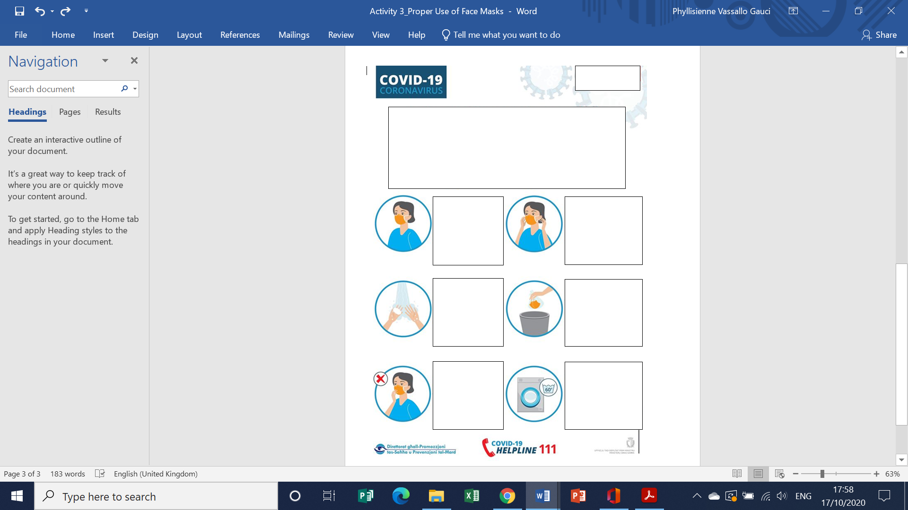**Complete the poster below with the necessary information in English and/or in your home language.**

1. [International Standard Classification of Education (ISCED) - Statistics Explained (europa.eu)](https://ec.europa.eu/eurostat/statistics-explained/index.php?title=International_Standard_Classification_of_Education_(ISCED))