**Title**: “Weathering the words: Talking about forest fires and extreme weather”

**Created by**: Alexandra das Neves, Carolina Machado, Lurdes Seidenstricker

**Short description**: In this lesson, A2/B1 learners will explore the vocabulary of extreme weather, focusing on forest fires. Through interactive video activities, discussions, and creative tasks, students will develop practical language skills for discussing real-world environmental issues.

**Languages activity is designed for**: German, adaptable to other languages.

**Age group**: 11-18+

**Level**: A2, B1

**Learning outcomes**:

By the end of this lesson, A2/B1 learners will be able to:

1. **Understand and use key vocabulary** related to extreme weather and forest fires, including words like *Waldbrand*, *trocken*, and *Feuerwehr*.
2. **Comprehend and respond to simple spoken and written texts** on the topic of extreme weather, including a video about extreme weather events.
3. **Engage in basic discussions** about the causes, consequences, and prevention of forest fires, using appropriate vocabulary and structures.
4. **Complete written tasks** such as gap-fill exercises and short texts about extreme weather, demonstrating control over the new vocabulary.
5. **Create and present a poster or infographic** on the topic of forest fire prevention, applying the vocabulary and concepts learned during the lesson.

**Skills**: Listening, Speaking, Reading, Writing, Interaction, Vocabulary, Mediation.

**ICT tools used**:

* Mentimeter
* EdPuzzle:
  + Link for colleagues: [https://edpuzzle.com/media/6742fd8b2904b2d50ed17556](%20https://edpuzzle.com/media/6742fd8b2904b2d50ed17556)
  + Link for using / sharing with: students: <https://edpuzzle.com/media/6742fd8b2904b2d50ed17556>
* Canva / Google Slides / Microsoft PowerPoint
* Video Platform: ZDF Logo! <https://www.zdf.de/kinder/logo/extremwetter-einfach-erklaert-100.html>
* Google Forms

**Duration in minutes:** 120+

**Will students be marked**? Yes

**Timing**: Approximately 3-4 sessions of 45-50 minutes.

**Description of each stage of the activity:**

**Session 1:**

1. Introduction to the Topic (10–15 minutes)

Learners talk about different types of weather and extreme weather, activating prior knowledge. (Mind maps / pictures)

2. Vocabulary Matching (10–15 minutes)

In pairs, learners match vocabulary with definitions related to forest fires such as *Waldbrand*, *trocken*, or *Feuerwehr.*

3. Watching the Video with EdPuzzle (20–25 minutes)

They then watch a video on *ZDF logo!* on extreme weather. Using EdPuzzle (links above), they answer interactive questions to reinforce vocabulary and comprehension.

**Session 2:**

1. Gap-filling Exercise (15–20 minutes)

Learners do a gap-filling activity using a simplified text about forest fires, reinforcing vocabulary usage.

2. Group Discussion (20–25 minutes)

Guided by the teacher, learners discuss the causes, consequences, and prevention of forest fires, using the newly learned vocabulary. They share their answers with the class. (If necessary, learners can previously prepare flashcards with relevant topics)

3. Poster/Infographic Creation (start) (15–20 minutes)

Learners design a poster or infographic about forest fire prevention, using vocabulary, appealing slogans and key ideas from the lesson.

**Session 3:**

1. Poster/Infographic Creation (finish) (25–30 minutes)

Learners finish their posters or infographics, preparing for a short presentation.

2. Presentations and Discussion (15–20 minutes)

Groups present their posters to the class, explaining their ideas about forest fire prevention using the target vocabulary. After that, they receive some informal peer and teacher feedback.

3. Assign Homework (5–10 minutes)

Individually, learners write a short text about an extreme weather event, using at least five newly learned vocabulary words.

**Suggestions for learner assessment/self-assessment/feedback/peer feedback:**

It is possible to create a rubric to score each element of the lesson sequence, using a 1–5 scale (or similar), with the following criteria:

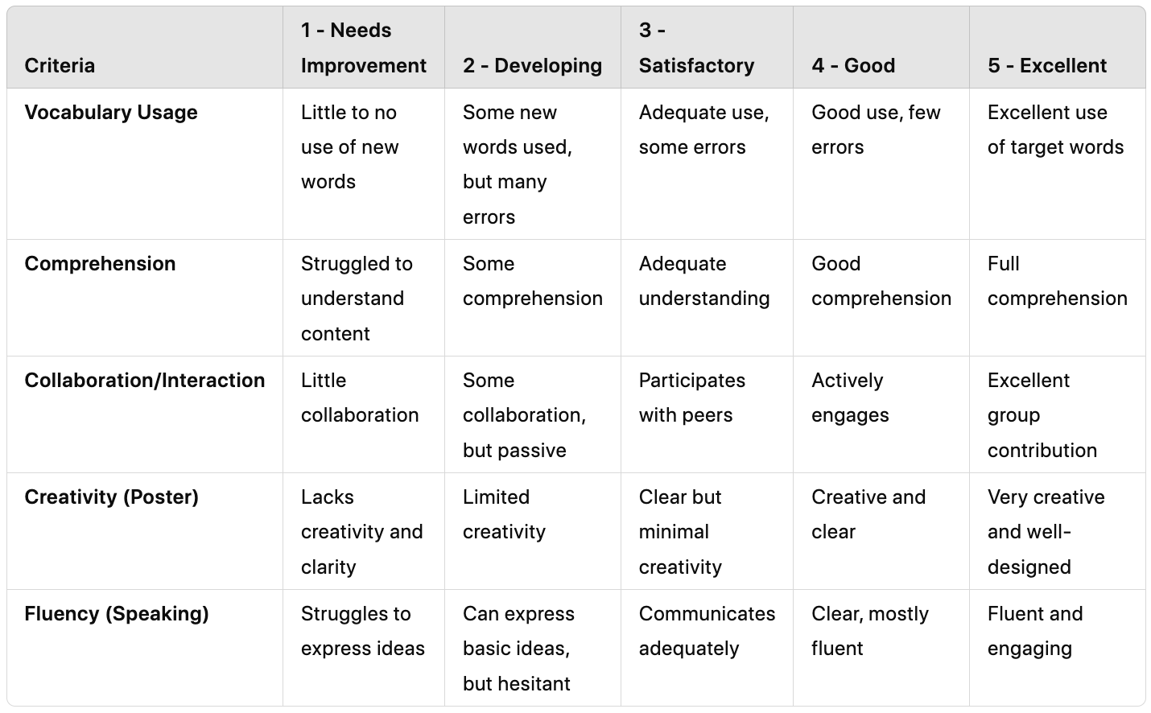

**Post-evaluation of the activity**: You can gauge learning success by using the following material:

*Quick Exit Survey:*

* At the end of the sequence, hand out a brief survey (on paper or through a digital tool like Google Forms). Keep the questions simple and specific, such as:
  + *Which activity helped you learn the most? (e.g., video, discussion, poster creation, etc.)*
  + *What was the most challenging part of the lesson?*
  + *Do you feel more confident using the new vocabulary? Why or why not?*

**Personal comments from the authors**: Some ideas in this learning activity have been powered by AI.

[](https://creativecommons.org/licenses/by-nc-sa/4.0/)

Attribution: Original activity from “Use of ICT in support of language teaching and learning (ICT-REV)”, European Centre for Modern Languages of the Council of Europe. [www.ecml.at/ictrev](http://www.ecml.at/ictrev)