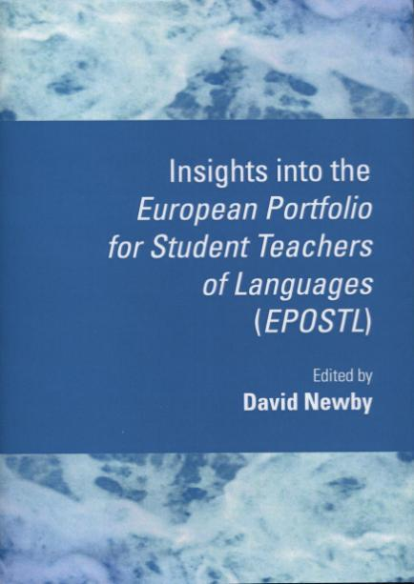

Published by
Cambridge Scholars Publishing,
January 2012
£39.99 from Cambridge Scholars Publishing www.c-s-p.org
£37.99 from Amazon, UK
Insights into the European Portfolio for Student Teachers of Languages
This book is intended principally for two groups of readers: teacher educators involved in the training of teachers of foreign languages and student teachers. However, it will be of interest to anyone involved in language education. The book is divided into three parts:
Part I: The theoretical basis of the EPOSTL
This section focuses on theoretical insights relevant to the use of the EPOSTL. In chapter one, David Newby discusses some of the issues which arose in the design of the EPOSTL and in its implementation. The most important function of the EPOSTL is as a tool for reflecting on the competences which teachers strive to attain. In the second chapter Anne-Brit Fenner therefore considers the role of reflection in education, looks at different theoretical approaches to reflection and indicates the role that it plays when the EPOSTL is used. A further aim of the EPOSTL is to support an autonomous mode of learning, both on the part of student teachers and their learners. In chapter three, Hanna Komorowska discusses the concept of learner autonomy and its place in education. In the last chapter of this section, Michael Byram presents a model of culture and analyses to what extent this model is represented in the descriptors of the EPOSTL.
Part II: The EPOSTL and other European instruments
As stated above, the EPOSTL builds on insights from three other European publications, each of which is the focus of a chapter in this part. In chapter five, David Newby examines the relationship between the EPOSTL and the Common European Framework of Reference, focusing on the correspondences between their respective competence descriptors. In chapter six, Hanna Komorowska explains the rationale of the European Language Portfolio and examines similarities and differences between the ELP and the EPOSTL. In chapter seven, Mike Grenfell, one of the co-authors of the European Profile for Language Teacher Education, presents its aims and content and indicates how the two documents may be used in a complementary fashion in the curriculum design of teacher education.
Part III: Implementing the EPOSTL
In the final part, three case studies are presented, illustrating how the EPOSTL can be used in practice. In chapter eight, in the first of these studies, Barbara Mehlmauer-Larcher describes how the EPOSTL is used in the training of future English teachers at the University of Vienna and also discusses theoretical aspects of her approach. The context she describes represents the ‘mainstream’ use of the EPOSTL; in the last two chapters, case studies are presented which show additional uses to which the EPOSTL can be put. Barry Jones describes a “bi-lateral” teacher education programme between the University of Cambridge and the Institut Universitaire de Formation des Maîtres at Antony in France, in which the EPOSTL played a key role. He further discusses reactions of the English and French students to using the EPOSTL. In the last chapter, Rita Kupetz and Hannah Ruhm give an account of how the EPOSTL was used in a short training course for German exchange assistants who were about to begin a period of teaching in the United Kingdom.

Table of Contents

Introduction 1
David Newby

Section I: The Theoretical Basis of the EPOSTL

Chapter One 9
The European Portfolio for Student Teachers of Languages:
Background and Issues
David Newby

Chapter Two 29
The EPOSTL as a Tool for Reflection
Anne-Brit Fenner

Chapter Three 51
Learner Autonomy and its Implications for the EPOSTL
Hanna Komorowska

Chapter Four 83
Reflecting on Teaching ‘Culture’ in Foreign Language Education
Michael Byram

Section II: The EPOSTL and Other European Instruments

Chapter Five 101
The EPOSTL and the Common European Framework of Reference
David Newby

Chapter Six 131
The EPOSTL and the European Language Portfolio
Hanna Komorowska

Chapter Seven 155
The EPOSTL and the European Profile for Language Teacher Education
Mike Grenfell

Section III: Implementing the EPOSTL

Chapter Eight 175
The EPOSTL: Promoting Language Teacher Learning in the Context
of Field Experiences
Barbara Mehlmauer-Larcher

Chapter Nine 195
Using the EPOSTL within a Bi-lateral Primary Modern Languages Teacher Training Programme
Barry Jones

Chapter Ten 217
The EPOSTL as a Tool to Document and Reflect on Teaching
Experiences Abroad
Rita Kupetz and Hannah Ruhm

Contributors 229

