FOR THE TEACHER
A newcomer in our class
Type of task: Helping around the newcomer, speaking and writing on a foreign language, intercultural exchange

Educational level: Primary education - ISCED 1
Proficiency level: A2

Short description and aim of the activity:
Students welcome a newcomer from Poland in our class. They learn how to describe our classroom rules to the newcomer by using the imperative form of verbs (affirmative or negative form) and the appropriate nouns and adjectives. They practise their skills in comprehending a short text in Language A and producing meaning in Language B.
The lesson plan consists of six steps, each containing three steps. Communicating classroom rules to a peer in another language is a common practise which can be taught in the classroom with steps 1-4, in the first part of the lesson plan. The second part (step 5) involves collaboration and creativity, as students make their own posters for our school’s classes. In the final part (step 6) students reflect upon their multilingual experience, producing short texts which will be published in our school’s blog.

Background information (if applicable): The written text in this lesson is in Greek as it is the official language in our school.

CEFR mediation scale and descriptor to which the activity refers:

RELAYING SPECIFIC INFORMATION IN SPEECH
- Can relay (in Language B) the point made in short, clear, simple messages, instructions and announcements, provided these are expressed slowly and clearly in simple language (in Language A).
- Can relay (in Language B) in a simple way a series of short, simple instructions, provided the original (in Language A) is clearly and slowly articulated.

PROCESSING TEXT IN WRITING
- Can convey (in Language B) the main point(s) contained in clearly structured, short, simple texts (in Language A), supplementing their limited repertoire with other means (e.g., gestures, drawings, words/signs from other languages) in order to do so
- Can use simple language to convey (in Language B) the main point(s) contained in very short texts (in Language A) on familiar and everyday themes that contain the highest frequency vocabulary; despite errors, the text remains comprehensible

TRANSLATING A WRITTEN TEXT IN SPEECH OR SIGN
- Can provide a simple, rough oral translation (into Language B) of routine
information on familiar everyday subjects that is written in simple sentences
(in Language A) (e.g., personal news, short narratives, directions, notices or
instructions).

Mediating concepts:
COLLABORATING IN A GROUP:
FACILITATING COLLABORATIVE INTERACTION WITH PEERS
- Can collaborate in simple, practical tasks, asking what others think, making suggestions and understanding responses, provided they can ask for repetition or reformulation from time to time.
COLLABORATING TO CONSTRUCT MEANING
- Can make simple remarks and pose occasional questions to indicate that they are following.
- Can make suggestions in a simple way.

Mediating communication:
FACILITATING PLURICULTURAL SPACE
- Can contribute to an intercultural exchange, using simple words/signs to ask people to explain things and to get clarification of what they say, while exploiting a limited repertoire to express agreement, to invite, to thank, etc.
ACTING AS AN INTERMEDIARY IN INFORMAL SITUATIONS (WITH FRIENDS AND COLLEAGUES)
- Can communicate (in Language B) the main point of what is said (in Language A) in predictable everyday situations, conveying back and forth information about personal wants and needs, provided other people help with formulation.

CEFR mediation strategies involved:

Strategies to simplify a text:
- Streamlining a text:
Can identify and mark (e.g., underline, highlight etc) the essential information in a straightforward informational text, in order to pass this information on to someone else.
Strategies to explain a new concept:
- Adapting language:
Can paraphrase in a simpler fashion the main points made in short, straightforward spoken or written texts on familiar subjects (e.g. short magazine articles, interviews) to make the contents accessible to others.

Languages involved:
Language A: Greek
Language B: English
Language C: home language (Polish)

Linguistic objectives. Students will be able to:
- convey main gist orally and in writing
- paraphrase information from one language to another
- describe classroom rules using the appropriate vocabulary

Cross-curricular teaching. School subjects involved:
- English
- Language
- Geography
- Art

Other competences involved:
- global citizenship: tolerance, openness, respect for diversity, cross-cultural understanding, multiculturalism, adaptability
- interpersonal skills: pair work, groupwork, communication, collaboration and social interaction
- critical and innovative thinking: self-reflection of multilingual experiences
- creativity: students’ drawings, create original work
- authentic writing: students address to an authentic audience, sense of ownership

Time/lessons needed for the activity: 2 lessons

Procedure:

 |  | Class organisation | Ideas for differentiation
Step 1 | In pairs, students talk about the classroom rules that they should follow during the lesson and write down three classroom rules, they choose.  The teacher may elicit or provide some useful language (verbs, nouns, adjectives or adverbs) that students can use when discussing with their peers and write them on the board. | Pairs
Step 2 | Students read a set of rules in Greek (Language A) and orally present the overall information in English. The classroom rules are written on a poster, which is produced in Greek by the students and the teacher. | Pairs
Step 3 | Students fill in a table with the verbs they used for their presentation | Pairs | Students with different home languages could also provide verbs in their language having the same meaning.
Step 4 | Students work in groups and try to transfer the classroom rules in English. | Groups
Step 5 | Students are asked to write a text in English to be included in their diaries on those classroom rules that it is difficult for them to follow? This task requires students to read information in Greek (Step 2) and relay some of them in a text of a different genre in English | Individual
Step 6 | Students reflect on their multilingual practise and write down (in Language A, B or C) one situation where they have engaged in mediation activities.  The text should be up to 50 words, and it will be published to our school blog in the cultural exchanges’ corner. | Individual

Extra resources:

Step 3 asks students to write down any verbs they used in order to carry out the tasks in Step 1-2. Here is an indicative list that can be of use by the teacher.

Verbs for describing classroom rules

- Raise
- Listen
- Speak
- Be
- Tidy
- Throw
- Go out
- Walk
- Run
- Help
- Need

Further tips and guidance:
The teacher may want to write on board the verbs for describing the classroom rules right from the beginning along with other useful language. Moreover, the teacher may want to remind the use and the formation of imperative (affirmative and negative).
Suggestions and ideas for adapting/differentiating for different contexts:
- The class teacher and the teacher of English could organise a common lesson focusing on students’ countries of origin.
- Despite the young age of students, the particular lesson plan can be adapted to the needs of older students using more sophisticated vocabulary items.

FOR THE STUDENT: ACTIVITY WORKSHEET
A newcomer in our class
Step 1
A. Work in pairs. Each partner thinks of the classroom rules that we should follow during the lesson.
B. Then, on a piece of paper, write down three classroom rules in Greek (or any other language s/he feels comfortable with)
Step 2
Work in pairs. A new student from Poland, Paolina, joined our class two weeks before. She wants to adjust to the new school environment. Since she does not speak Greek, you can help her around, starting with our classroom rules.
Read carefully the classroom rules on the poster.
A. Before you start talking, write down in note form the verbs that you are going to use to describe our classroom rules.
B. Orally describe them in English to Paolina.
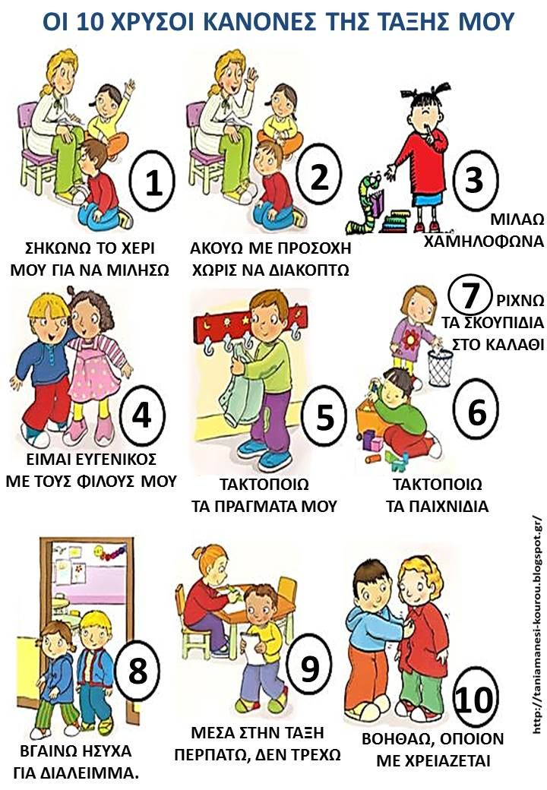
(Text taken from: http://taniamanesi-kourou.blogspot.com/2013/07/16.html?spref=pi – accessed 8 August 2023)
Step 3
Work in pairs. Which verbs did you use in order to describe the classroom rules mentioned in the text above? Fill in the table below.

Verb I used in English | Word in home language with the same/similar meaning (if applicable)

Step 4
Work in groups. Write the classroom rules in English. Use the verbs from the above list and the relevant vocabulary from the board.

Step 5
What classroom rules is it difficult for you to follow? Write a text in English to be included in your diary. Use ideas from Step 2.

Dear diary,
Today we created a poster on classroom rules at school. However, not all of them ….

Step 6
Write about a situation where you had to provide someone with instructions or directions in English, because he/she could not speak Greek. Your text should be up to 50 words, and you can use English, Greek or any other language you wish. The texts will be published to our school blog in the cultural exchanges’ corner.

The METLA team deeply thanks Katerina Aisopou, foreign language teacher in Greece, who, on the basis of the METLA task description template, created this activity.
International Standard Classification of Education (ISCED) - Statistics Explained (europa.eu)

